**How To Upload Webpage’s To Infinityfree.net**

**1.** Go to <https://infinityfree.net/>

**2.** Click on “client area”

**3.** The login is:  
  
**Email:** rollestonmathematics@rollestoncollege.nz  
**Password:** M@ths2707

**4.** Once logged in, click on “Manage”

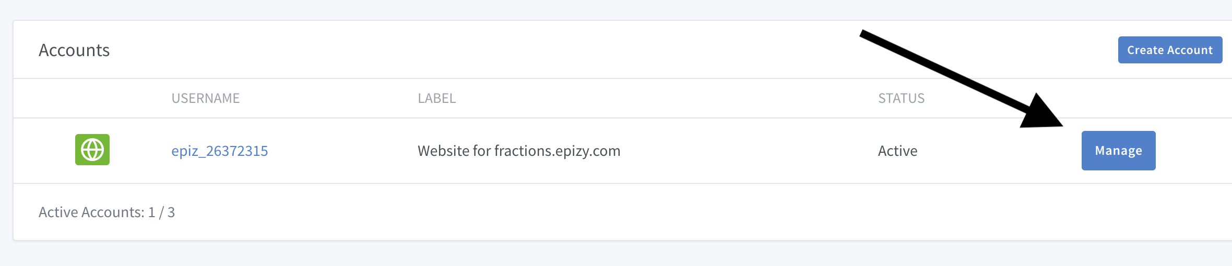

**5.** Click on “File Manager”

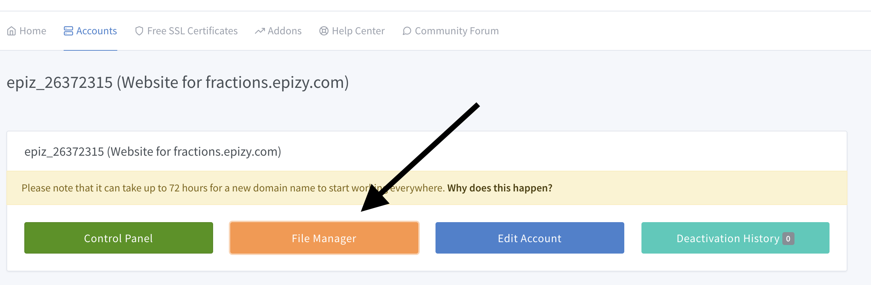

6. If you are asked to log in the password is:  
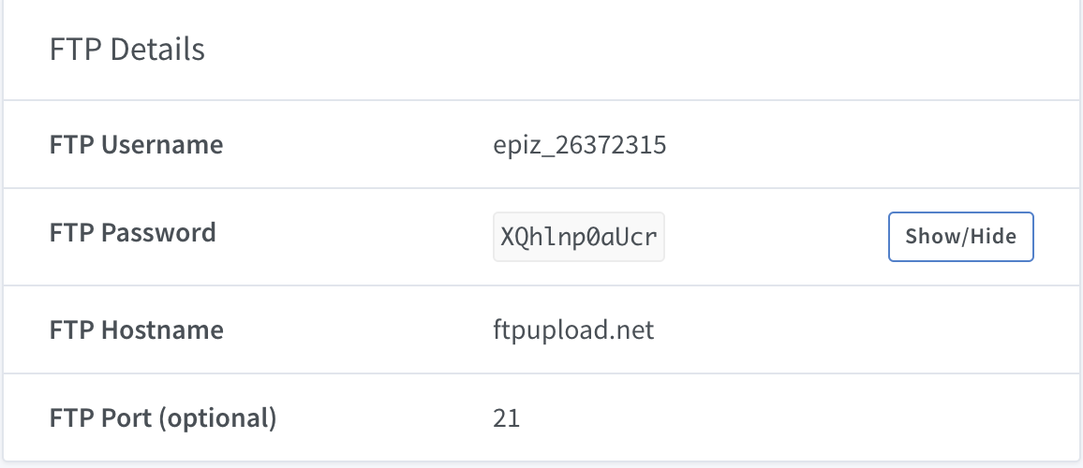**Password:** XQhlnp0aUcr

7. Once logged in, double click on the ‘htdocs’ folder

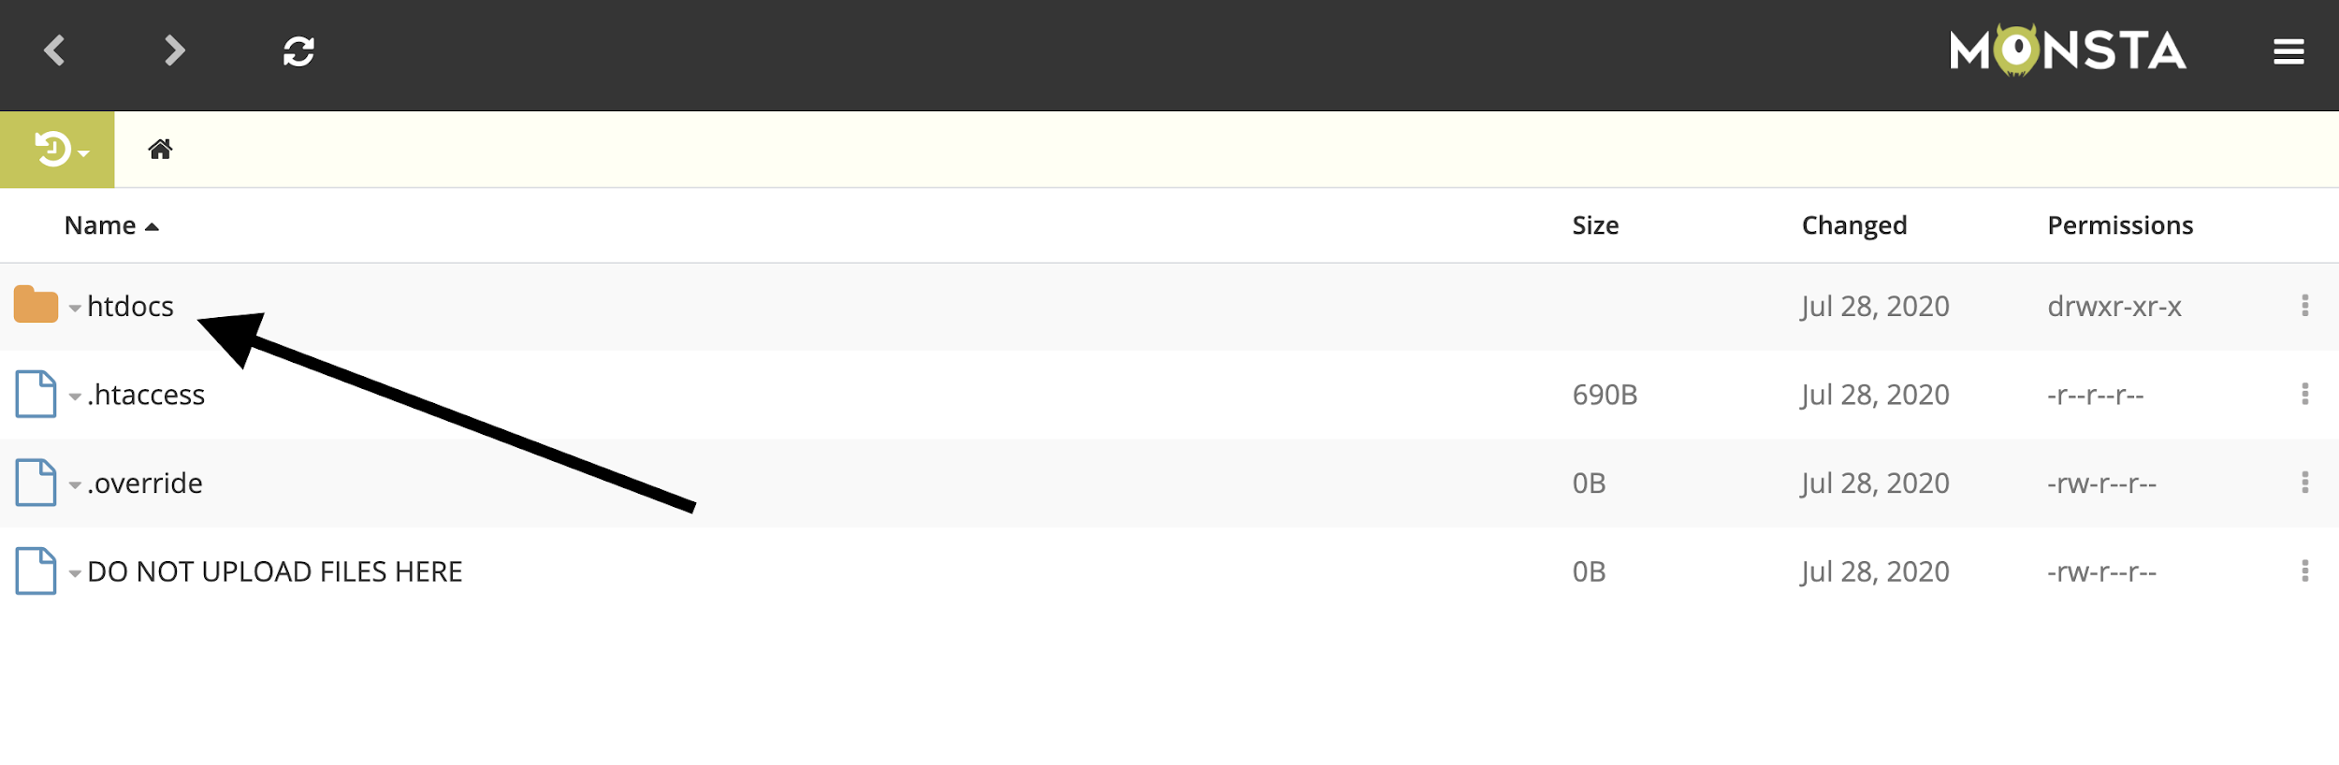

8. Down in the bottom-left corner you will see an ‘Upload’ button, 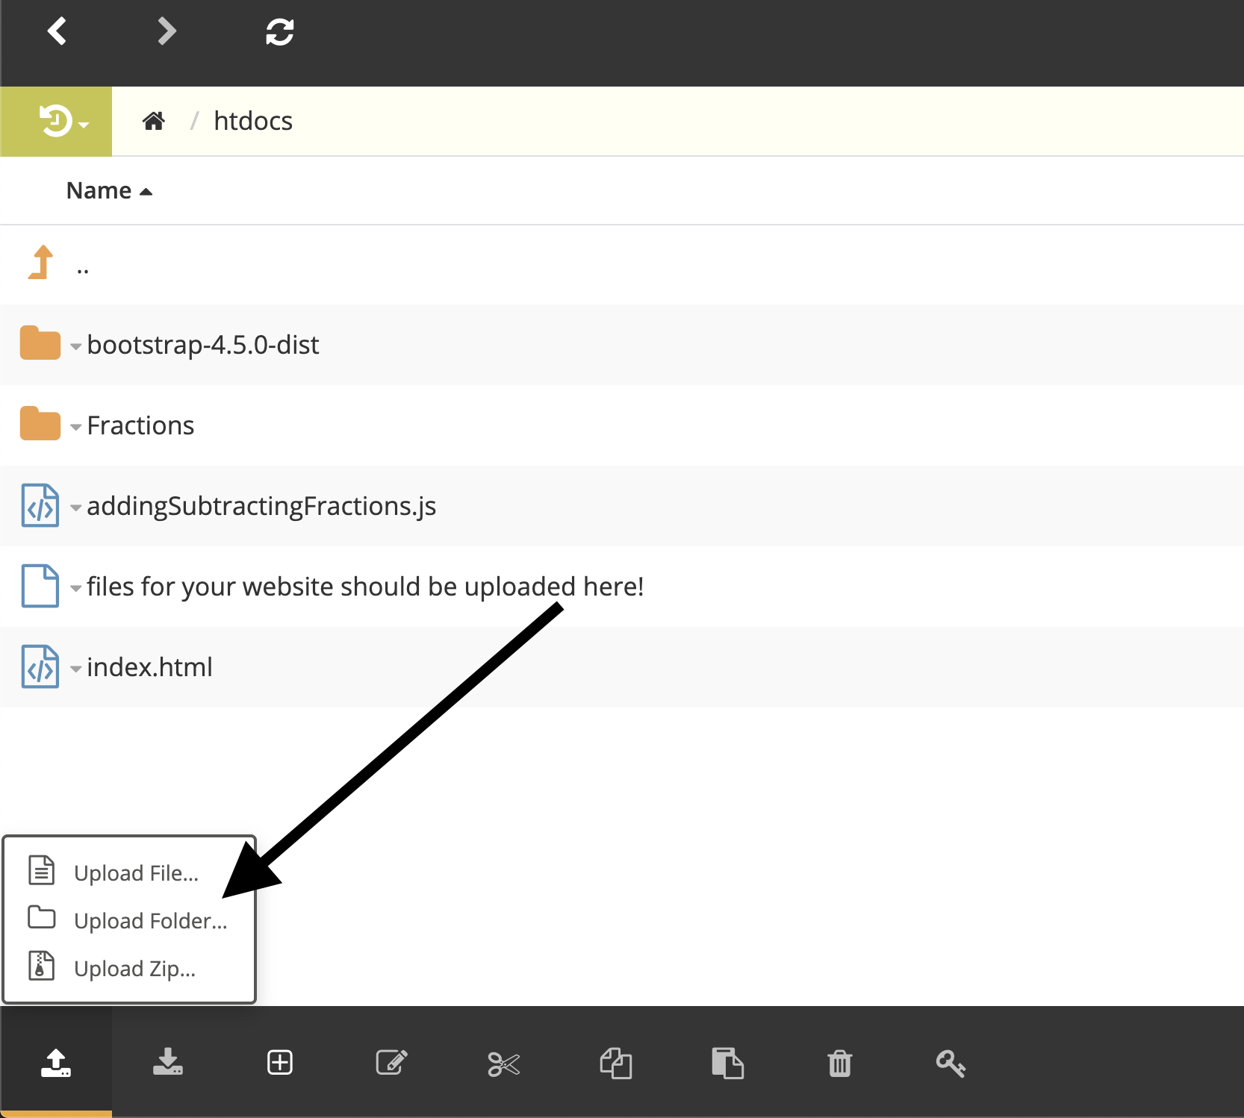there you can select if you want to upload a Folder or a File.

Please note if the file you are uploading calls to any outside files (eg. Javascript, CSS) that you include these and that the path to these files is reflected in your code.  
  
Once you have all of your files uploaded the link to your newly uploaded page will be [http://fractions.epizy.com/mynewwebpage](http://fractions.epizy.com/) with “mynewwebpage” being the name of the file that you uploaded. **More on this below**.

For example, if the file you have uploaded is the “add.html” shown above. The URL for this HAS to include the path/folders leading to the file with “htdocs” being the ROOT destination. So the URL is “fractions.epizy.com/Fractions/CommonDenominator/add.html”.